Deliverable 2: Technical Implementation

1. Data Handling
- Dataset: torchvision.datasets.FashionMNIST (60k train, 10k test).
- Preprocessing: All the images were processed through transforms transforms.ToTensor () (scaling to [0, 1]) and transforms.Normalize ((0.5,), (0.5,)) (normalizing to [-1, 1]).
- Splitting: With sklearn.modelselection.traintestsplit a 60,000-image training set was split into 48,000 image (80) training set, and 12,000 image (20) validation set. Importantly, stratify=traindataset.targets was done to keep the balance in the classes in both splits.
- Loaders: All sets with a batch size of 64 were loaded using DataLoader. The training loader had shuffle=True and the validation and test loaders did not.

2. Network Topology
These two models were classes of nn.Module and transferred to the cuda device.
- ANN (MLP): A basic 3-layer Multi-Layer Perceptron. The 28x28 image was reduced to a 784-elements vector.
  - Architecture: Linear(784, 128) -> ReLU -> Linear(128, 64) -> ReLU -> Linear(64, 10).
- CNN: A two-layer Convolutional Neural Network which is used to extract spatial features.
  - Feature Extractor: Conv2d(1, 32, k=3, p=1) -> ReLU -> MaxPool2d(2, 2) -> Conv2d(32, 64, k=3, p=1) -> ReLU -> MaxPool2d(2, 2).
  - Classifier Head: The 64x7x7 feature map was flattened to a 3136-element vector.
  - Architecture: Linear(3136, 128) -> ReLU -> Dropout(0.25) -> Linear(128, 10).

3. Training Setup
- Loss Function: nn.CrossEntropyLoss that is the standard multi-class classification loss, as it is a combination of LogSoftmax and NLLLoss.
- Optimizer: optim.Adam has been selected due to the adaptive learning rate and rapid convergence.
- Hyperparameters: The two models were run with 10 rounds and constant learning rate of 0.001.

4. Evaluation and Analysis
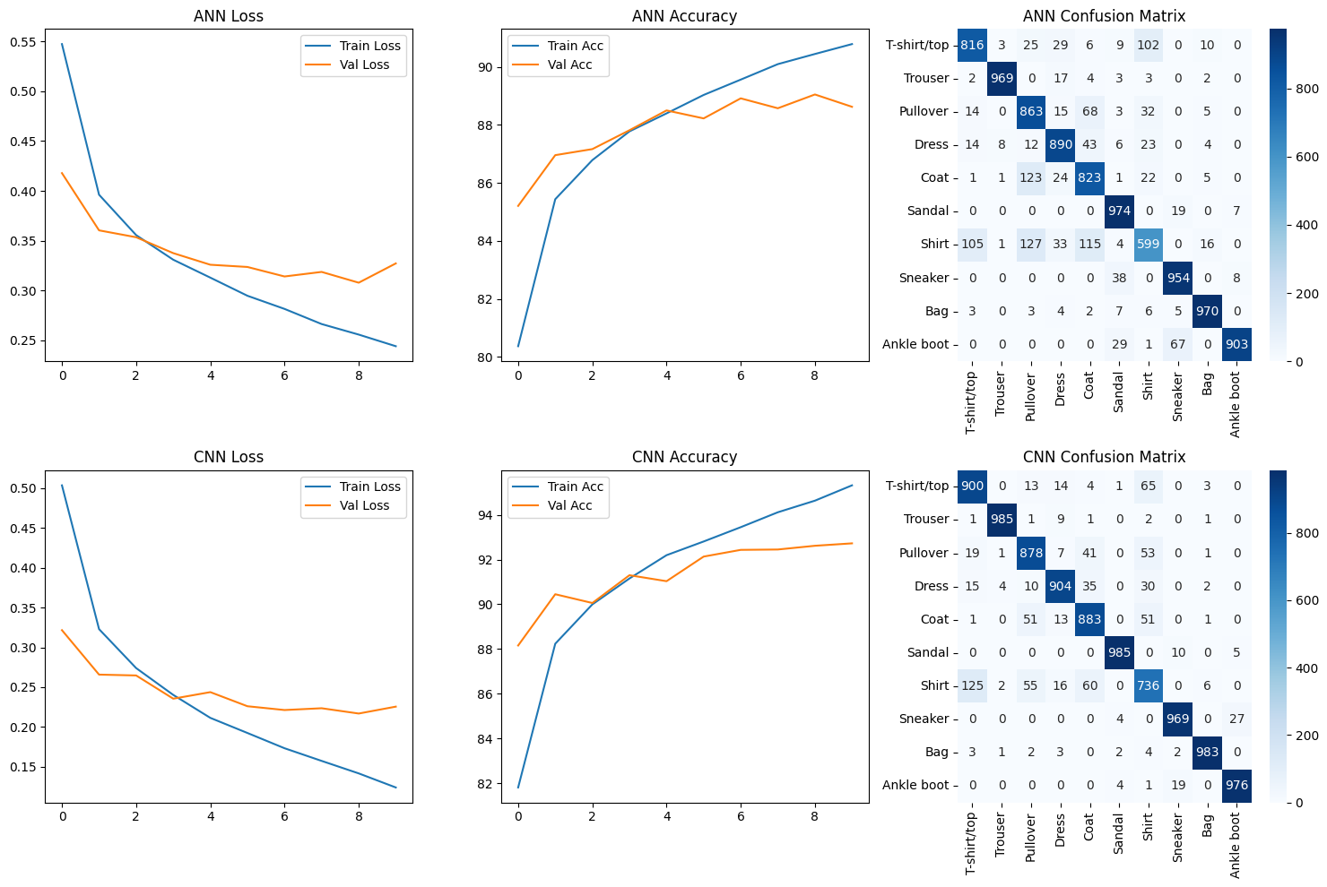
- Overall Performance: CNN was far better than ANN in terms of overall performance on the 10,000-image test set.
  - ANN Test Accuracy: 87.61%
  - CNN Test Accuracy: 91.99%
- Training Curves:
  - The Loss/Accuracy plots clearly indicate that ANN started to overfit after the second/third epoch; its training loss (blue) continued to reduce but its validation loss (orange) leveled and increased.
  - The curves of the CNN were followed significantly more, meaning more perfect generalization. This is because it has a better architecture and aDropout(0.25) layer used to regularize it.
- Confusion Matrix & Class Analysis:
  - When the ANN is confused (high confusion), the confusion is evident on the confusion matrix (top right): classes with high similarity (in visual expectation) include; Shirt (6), T-shirt/top (0), Pullover (2) and Coat (4) have high confusion.
  - The CNN matrix (bottom right) is far more cleaner to the extent that higher values are distributed around the diagonal, which demonstrates its superior capability of differentiating these items.
  - Key Failure Case: The most difficult one was the class of Shirt (index 6). The ANN was extremely poor (0.60 or 60 percent) in recall. The CNN was far superior and recorded an accuracy of 0.74 (74) on the same category.

5. Critical Analysis: ANN vs. CNN
The difference in the accuracy at 4.38% is not insignificant; it is based on a structural difference in design. The ANN flattens the image which ruins all the spatial information. It treats pixels as a list of 784 things and is incapable of learning local features such as edges, corners, or textures. It is only able to learn global pixel patterns and that is why it mixes 'Shirt' and Coat (they share similar overall shape of silhouette).
The CNN is remarkable due to the fact that its convolutional filters are learnable feature detectors, which scan an image on a 2D basis. Simple edges are learned in the first layer, and the following layer makes them into more complex shapes (such as pockets, collars or lapels). The hierarchical manner of feature extraction in this case enables the CNN to develop a rich, spatial interpretation of the image that makes it differentiate between things considered identical by the ANN.

6. Reflection and Improvements
- Data Augmentation: Adding transforms.RandomHorizontalFlip and transforms.RandomRotation(10) to the transform pipeline of the training data will be the best addition. This would generate additional data, strengthen the model and directly deal with the overfitting that is evident in the ANN.
- Learning Rate Scheduling: The optimizer should be trained with torch.optim.lr_scheduler.ReduceLROnPlateau to monitor validation loss, which would then enable the optimizer to cool down and find a superior minimum, probably eliciting an additional 0.5-1% of accuracy.
- Architecture Tweaks: Stabilizing and accelerating training with the CNN would be achieved by adding nn.BatchNorm2d after every Conv2d layer. nn.Dropout layers between the linear layers of the ANN would have done the ANN a favour to combat its obvious overfitting.

